H.T No
Regulations:
A18

Sreenidhi Institute of Science and Technology
(An Autonomous Institution)
Code No: 7EC01 Date: 16-Mar-2021 (AN)

B.Tech II-Year II- Semester External Examination, March/April - 2021 (Supplementary)
DATA STRUCTURES (ME and ECE)

Time: 3 Hours Max.Marks:70

Note: a) No additional answer sheets will be provided.
b) All sub-parts of a question must be answered at one place only, otherwise it will not be valued.
c) Missing data can be assumed suitably.

ANSWER ANY 5 OUT OF 8 QUESTIONS. EACH QUESTION CARRIES 14 MARKS.

Bloom's Cognitive Levels of Learning (BCLL)

Remember | L1 | Apply | L3 | Evaluate | L5
Understand | L2 | Analyze | L4 | Create | L6

 |  |  | BCLL | CO(s) | Marks
1. | a) | What is a Circular Queue? Briefly explain the basic operations of Circular Queue. | L2 | CO1 | [7M]
 | b) | Evaluate the Postfix Expression AB+CD/E*F%- using Stack. The values of the variables are a=2, b=3, c=5, d=2, e=4 and f=6. | L5 | CO1 | [7M]
2. | a) | Write an algorithm to insert a node at required position into a Single Linked List. | L2 | CO2 | [7M]
 | b) | Write a C program to implement Stack Operations using Linked List. | L2 | CO2 | [7M]
3. | a) | Write about representation of Binary Tree using Linked List. Represent the following Binary Tree using linked list representation.  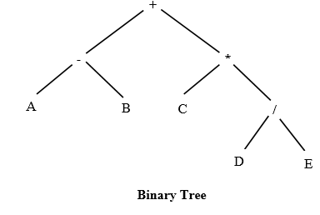 | L2 | CO3 | [7M]
 | b) | Explain different Rotation Patterns for balancing AVL trees with respect to Insertion operation of a data node | L2 | CO3 |  | [7M]
4. | a) | Trace the algorithm of insertion sort for sorting L= {16, 36, 4, 22, 100, 1, 54}. | L4 | CO4 | [7M]
 | b) | Explain about different operations that can be performed on Heaps. | L2 | CO4 | [7M]
5. | a) | Compare and contrast Structured programming with Object Oriented programming. | L4 | CO5 | [7M]
 | b) | Can we initialize a class/structure member variable as soon as the same is defined? Explain with an example. | L2 | CO5 | [7M]
6. | a) | Does C++ support overloading? If so what are the types of overloading and describe each with an example. | L2 | CO6 | [7M]
 | b) | Which operators can be used in C++ to allocate and release dynamic memory? Explain with an example. | L2 | CO6 | [7M]
7. | a) | Write a C Program to convert infix expression to postfix expression. | L2 | CO1 | [5M]
 | b) | What are the advantages of Linked lists over arrays? | L2 | CO2 | [5M]
 | c) | Differentiate between DFS and BFS. | L4 | CO3 | [4M]
8. | a) | Write a C code for Binary Search using linear arrays. | L2 | CO4 | [5M]
 | b) | Write a short note on Object Oriented Programming Concepts. | L2 | CO5 | [5M]
 | c) | With an example illustrate the purpose of “this pointer’ in C++” program. | L3 | CO6 | [4M]

-- 00 -- 00 –

